Sign In to Zoom Desktop with SSO
1. Download and open Zoom Desktop Client
2. Select “Sign In”
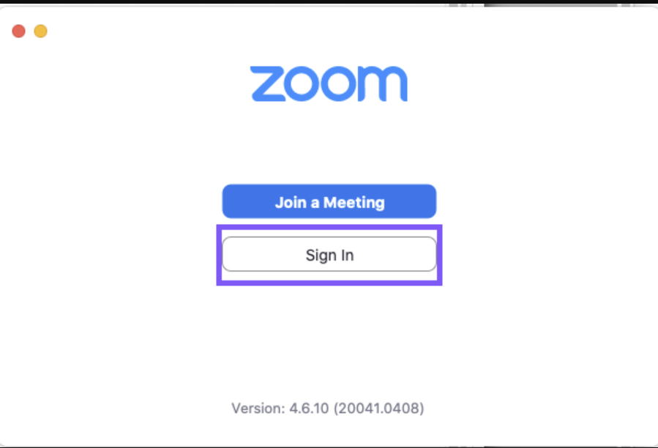
3. Select “Sign In with SSO”
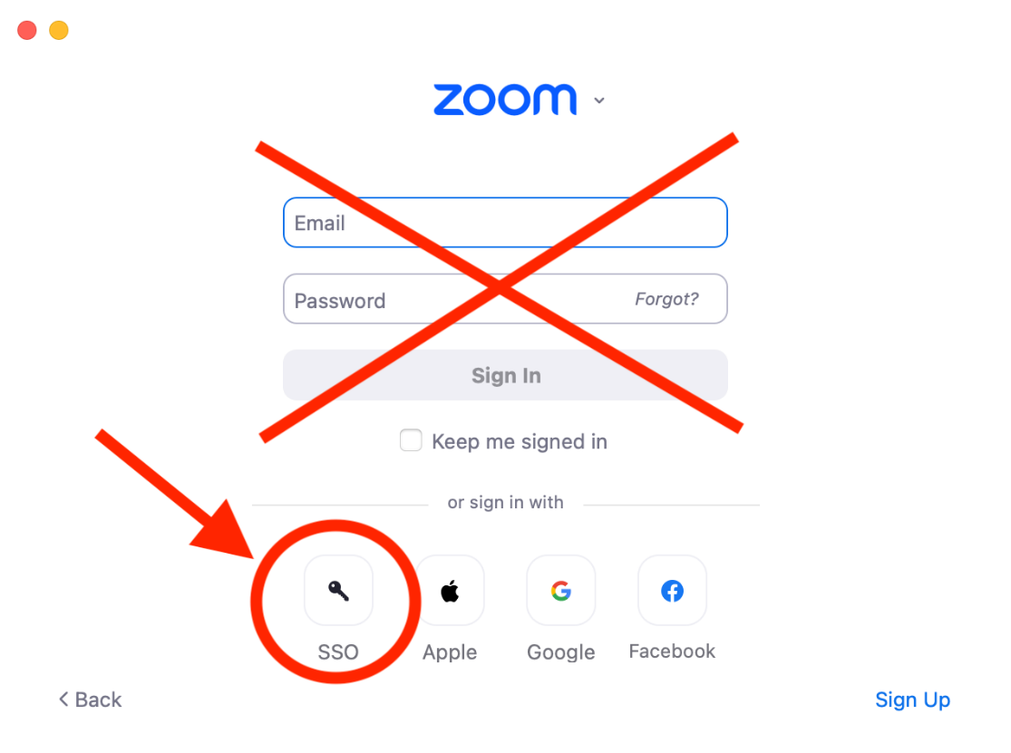
4. Enter “lsu” and select “Continue”
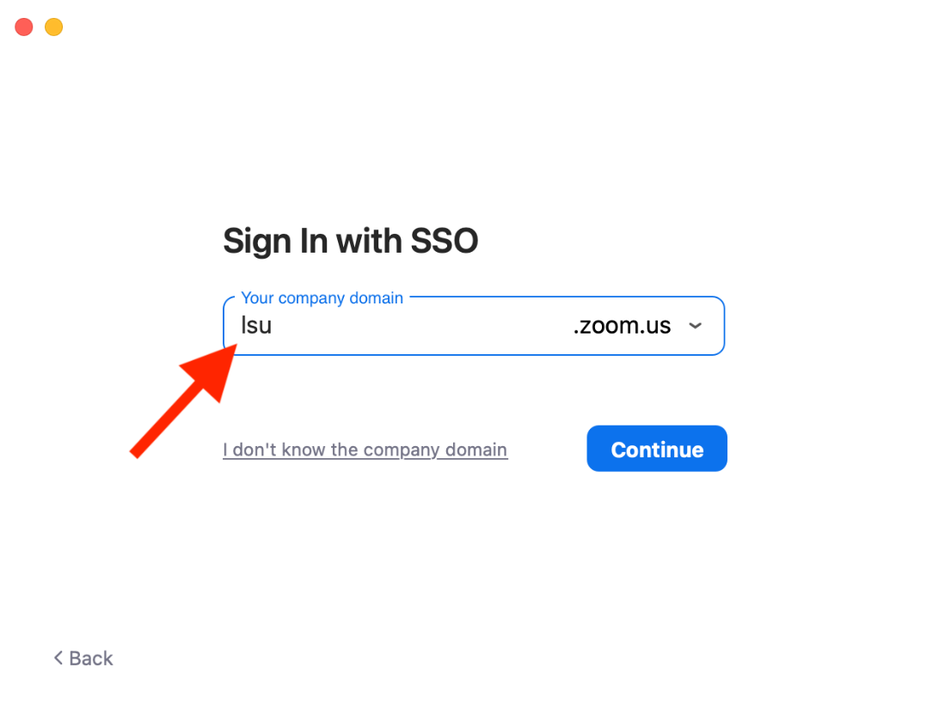
5. A web browser will open and you will be prompted to log in. Login and accept any prompts.
6. After the process completes you will be prompted to open Zoom.
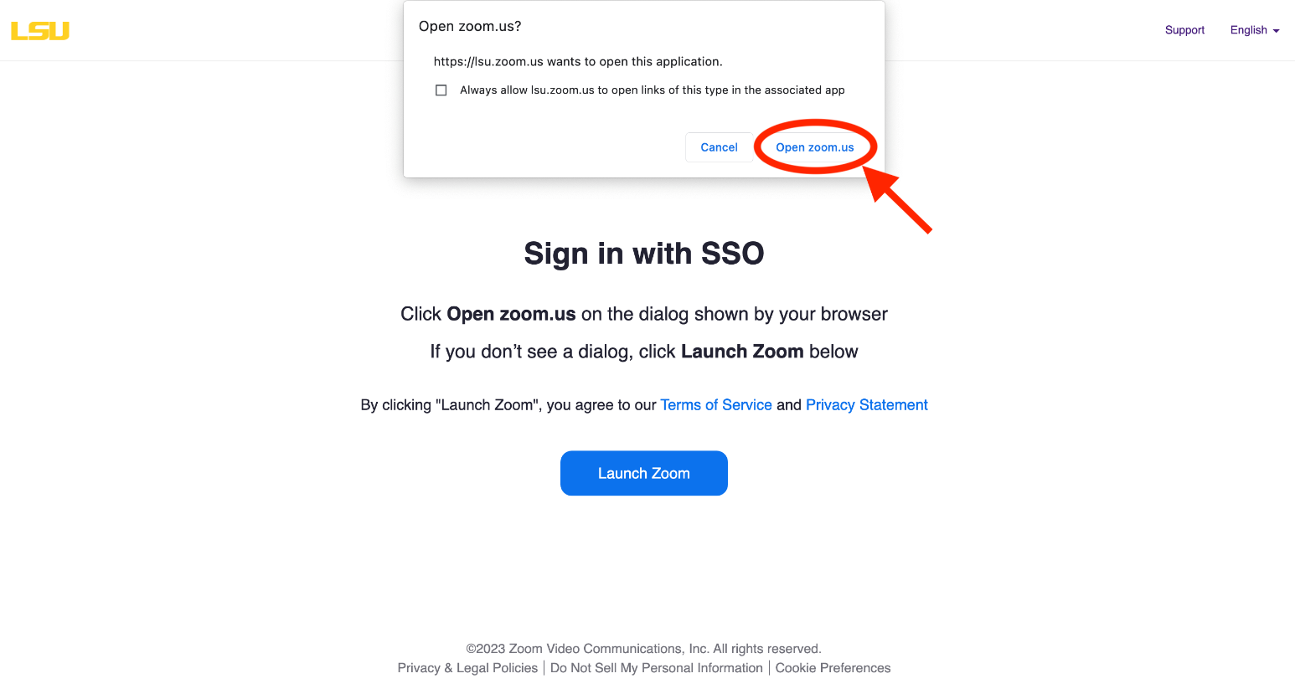
- You can check that you are correctly signed in by:
  - Selecting initials at the top right of the window
  - Verifying that you see “licensed”

